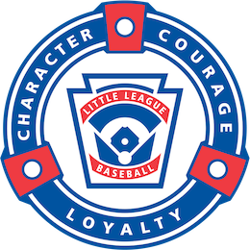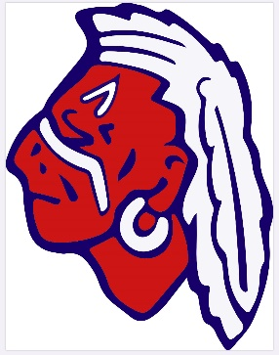Massapequa International

Little League, Inc.

P.O. Box 103, Massapequa Park, NY 11762

<https://www.massapequainternationalLL.com/>

Contact: [MILLsponsor@gmail.com](mailto:MILLsponsor@gmail.com)

Sponsorship Form

(Check Applicable Box)

Single Sponsorship- $350

**1-** Your company name on the back of a team jersey for ONE baseball or softball team.

**2-** Engraved plaque with your company name and team photo.

**3-** Your company listed on the M.I.L.L. website with a direct link to your company website.

***A discount rate of an additional $250 for each additional sponsored team.***

Double Sponsorship- $500

**1-** Please select one:

Your company name on the back of team jersey for ONE baseball or softball team.

OR

Baseball shaped sign with your company name on the outfield fence at Brady Park.

(There is typically 80+ baseball games played at Brady Park from April through September.)

**2-** Electronic sponsor advertising on the scoreboard at Brady Park. Scoreboard will be illuminated

for the 80+ games that are played at Brady Park for the duration of the season. This also includes

special events such as Opening Day, League Picnics, All-Star Weekend, etc.

**3-** Engraved plaque with your company name and team photo (photo only if jersey option is selected).

**4-** Your company listed on the M.I.L.L. website with a direct link to your company website.

Triple Sponsorship- $750

**1-**  Your company name on the back of a team jersey for ONE baseball or softball team.

**2-**  Engraved plaque with your company name and team photo.

**3-**  Your company listed on the M.I.L.L. website with a direct link to your company website.

**4**- Baseball shaped sign with your company name on the outfield fence at Brady Park.

(There is typically 80+ baseball games played at Brady Park from April through September.)

Home Run Sponsorship- $1,500

**1-** Everything included in the Triple Sponsorship.

**2-** A PRIME spot on our M.I.L.L. website.

**3-** Electronic sponsor advertising on the scoreboard at Brady Park. Scoreboard will be illuminated for

the 80+ games that are played at Brady Park for the duration of the season. This also includes special

events such as Opening Day, League Picnics, All-Star Weekend, etc.

**4-** Your company name as a sponsor on shirts or banner for special event (i.e. Opening Day, League

Picnics, All-Star Weekend.)

Thank you for supporting Massapequa International Little League!

Massapequa International

Little League, Inc.

P.O. Box 103, Massapequa Park, NY 11762

<https://www.massapequainternationalLL.com/>

Contact: [MILLsponsor@gmail.com](mailto:MILLsponsor@gmail.com)

Team Sponsor Information

Please complete both forms and return them along with payment

by February 1st 2022.

Sponsor Name:

Company Name on Team Jersey or Sign:

Sponsor Contact:

Sponsor Phone #:

Sponsor Business Address:

Sponsor Email:

Sponsor Website:

Player(s) Affiliation: Name:       DOB:

(*If applicable*)

Name:       DOB:

Team or Color Preference:

Amount Included $:

*Checks can be made payable to Massapequa International Little League (M.I.L.L) or*

*paid through VENMO @massapequainternationalLL*